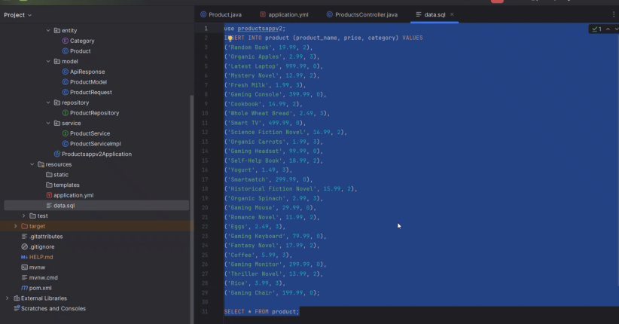

In controller do the changes

In product service and also in product service implementation.

ApiResponse

ProductModel – will only have the fields which I want to show to the user for this change product service and product serviceimpl

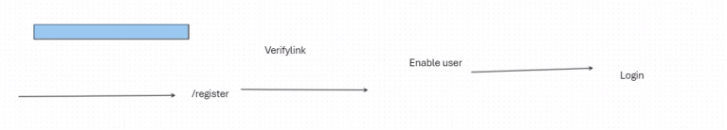

Dependencies : datajps, web, starter security connectorJ.

Create an spring initializer application add the dependencies

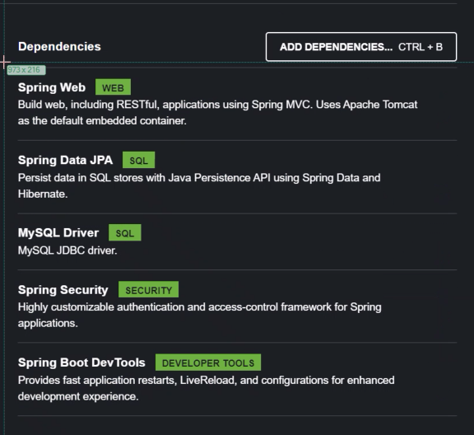

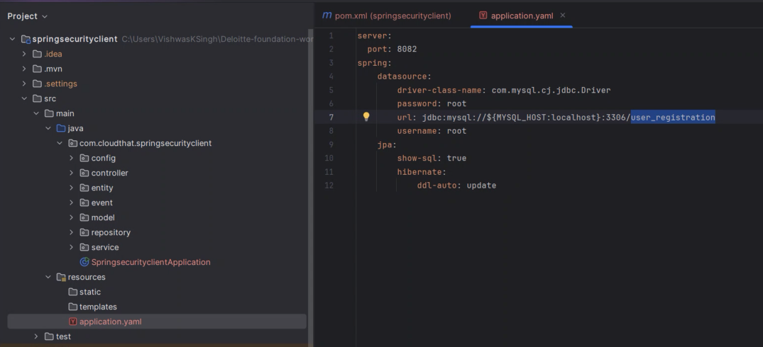

In database create a new database

Build a controller

For testing purpose HelloController

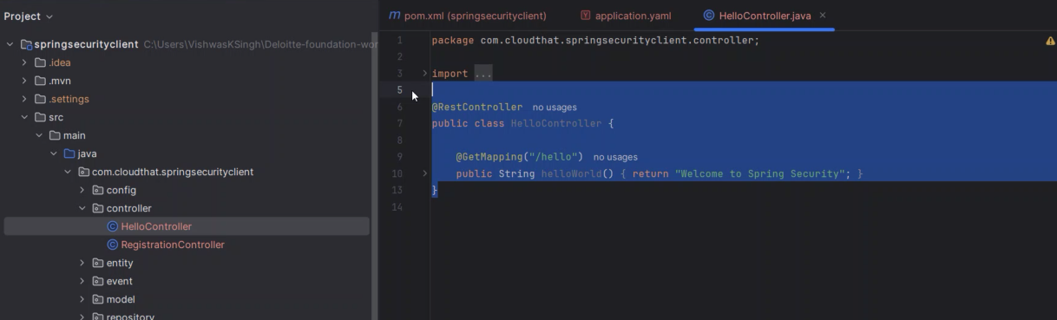

RegistrationController.java

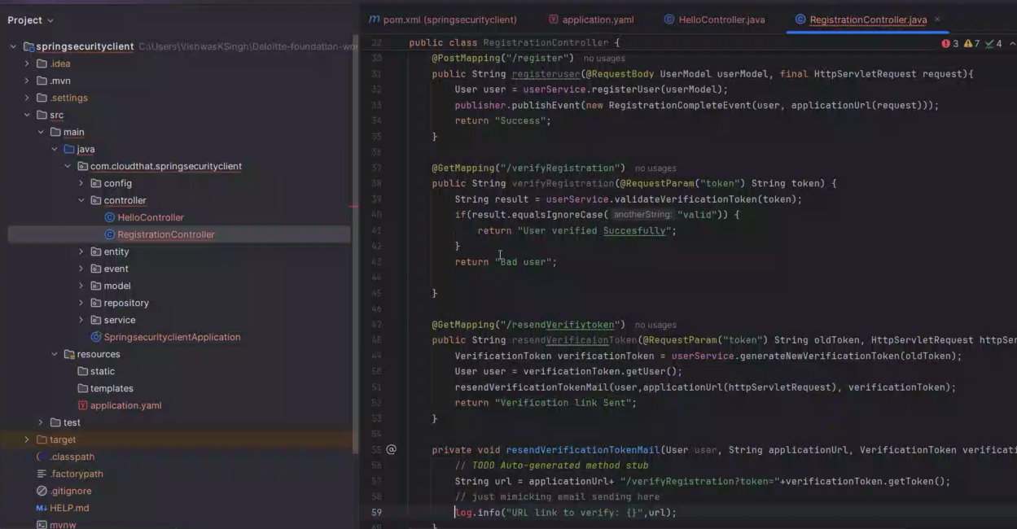

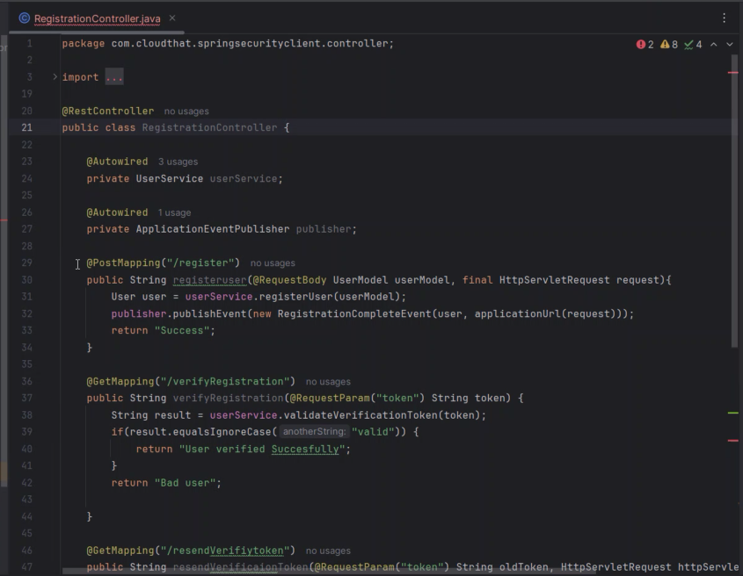

In Model package UserModel class

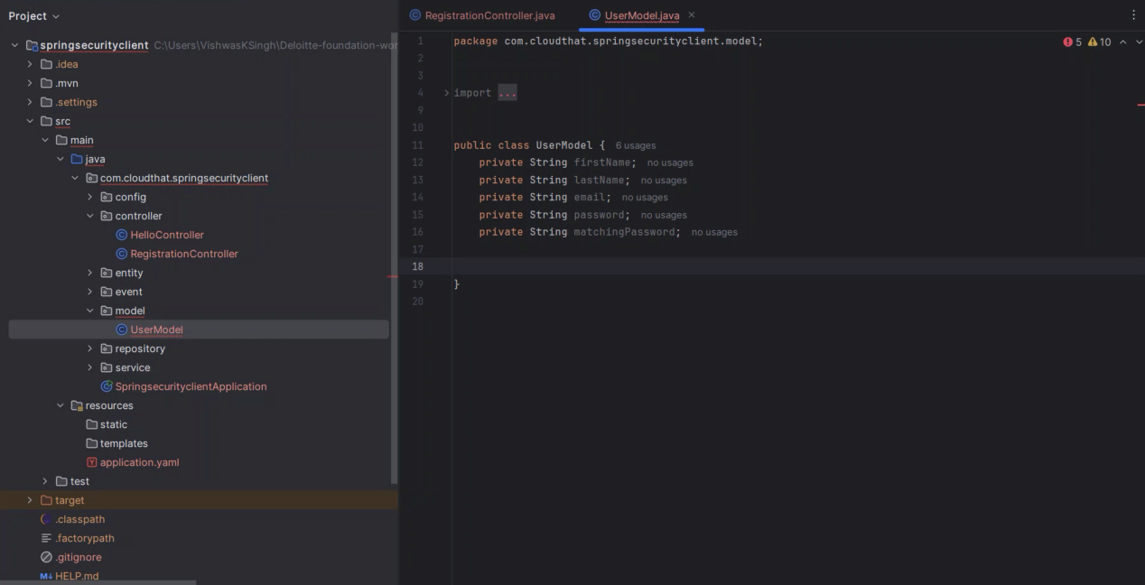

Generte getters and setters and no/all arguments constructor

Inside service package userService

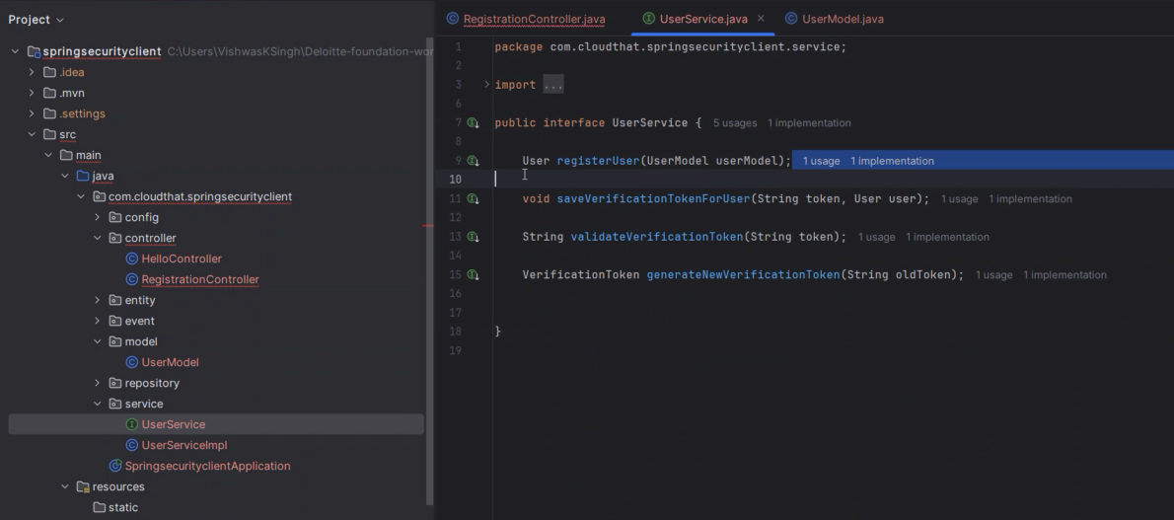

userServiceImpl

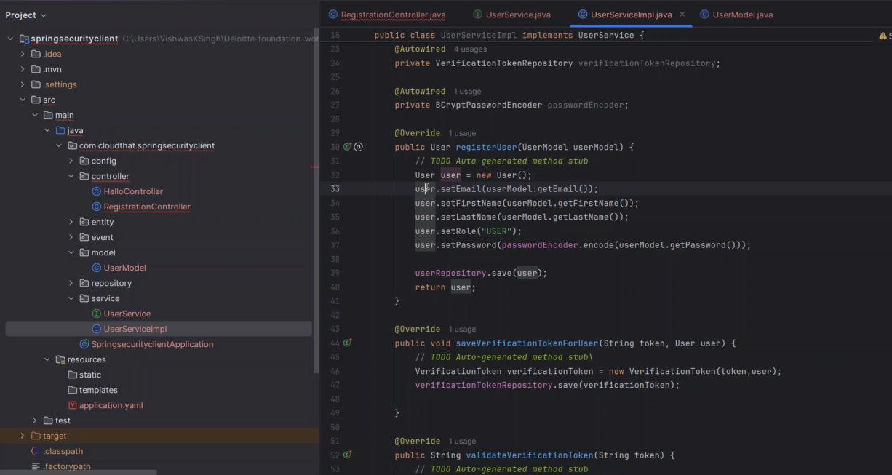

Inside event registrationCompleteEvent

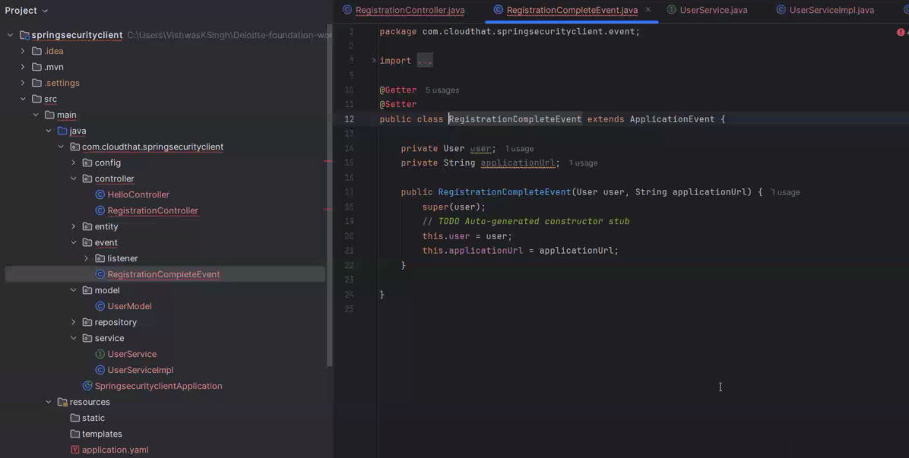

Generate getters and setters and constructor all

Inside event-listener in side listener listening the event of regiztrationCompleteEvenet

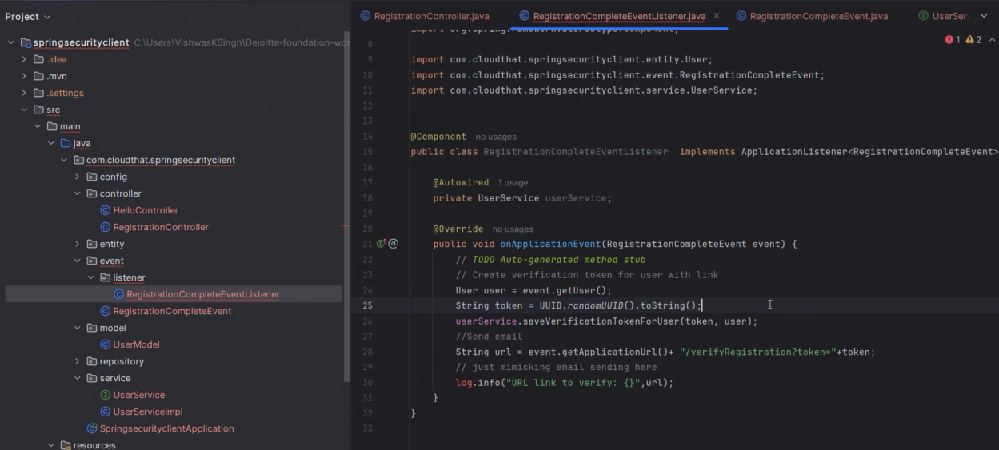

Then an token - uniqueId has to be generated. And it has expiration time also. And then we have to send an email but here instead of sending an email we are generating an url and opening it. And I the controller code we are returning “success”.

VERIFYREGISTRATION

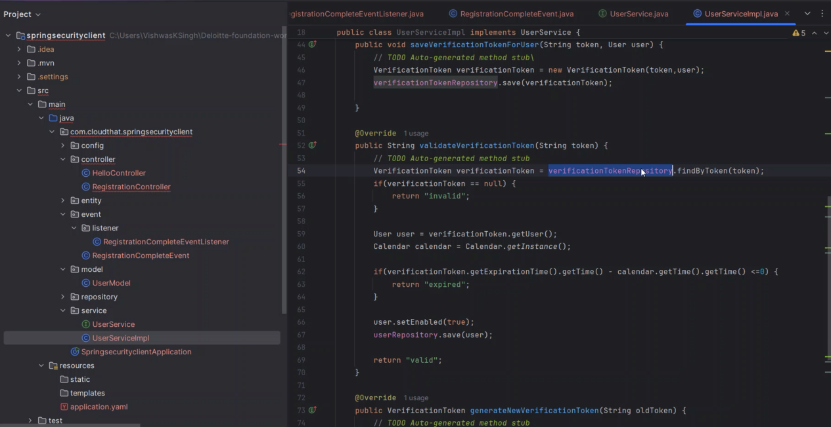

validateToken in UserServiceImpl

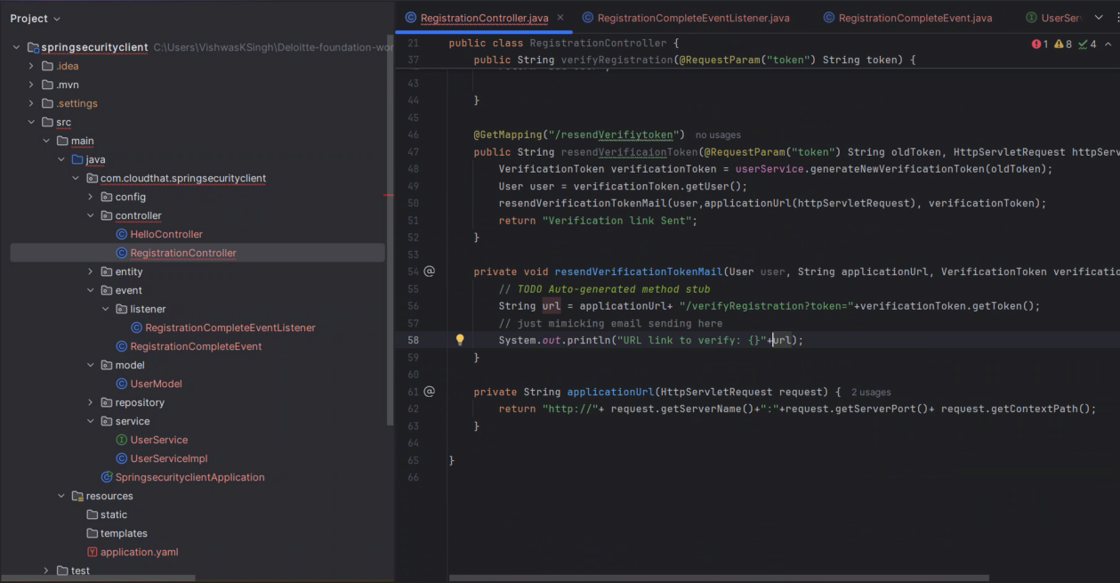

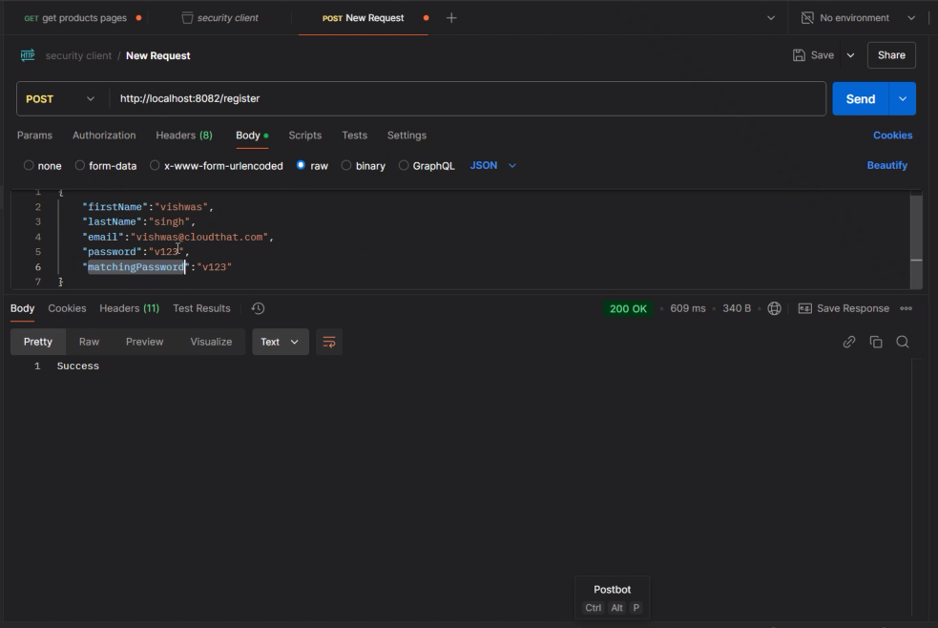

Refer sir code for above pogramming

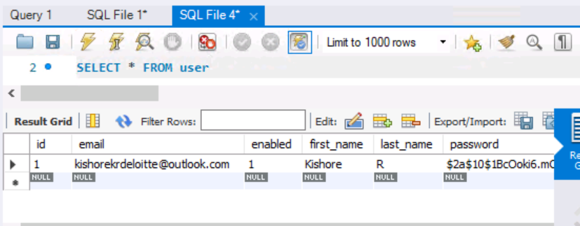

Controller>method>service>repo

In productappV2

In ProductsController.java

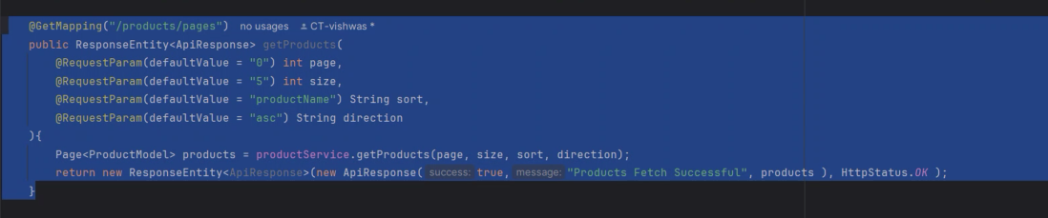

In Service package > productService



In Service package > productServiceImpl

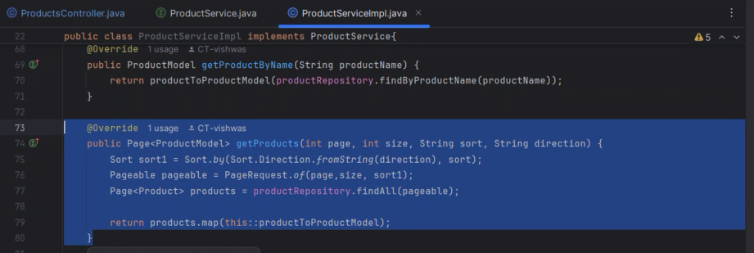

That return line is java 8 expression.

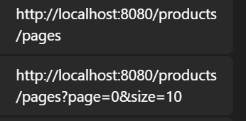

@GetMapping("/products/pages")public ResponseEntity<ApiResponse> getProducts( @RequestParam(defaultValue = "0") int page, @RequestParam(defaultValue = "5") int size, @RequestParam(defaultValue = "productName") String sort, @RequestParam(defaultValue = "asc") String direction){ Page<ProductModel> products = productService.getProducts(page, size, sort, direction); return new ResponseEntity<ApiResponse>(new ApiResponse(true,"Products Fetch Successful", products ), HttpStatus.OK );}

Page<ProductModel> getProducts(int page, int size, String sort, String direction);

@Overridepublic Page<ProductModel> getProducts(int page, int size, String sort, String direction) { Sort sort1 = Sort.by(Sort.Direction.fromString(direction), sort); Pageable pageable = PageRequest.of(page,size, sort1); Page<Product> products = productRepository.findAll(pageable); return products.map(this::productToProductModel);}